**RESPONSE PLAN OF**

**DHULIKHEL HOSPITAL FOR NOVEL CORONA VIRUS (nCoV) INFECTION**

January 28, 2020

In response to the alert from Health Emergency Operation Centre (HEOC), an emergency meeting was held at Dhulikhel Hospital on 27th Jan 2020 in the presence of representatives from different departments including administration, procurement, hospital infection prevention committee, nursing department etc., and following conclusions were drawn:

1. Hospital will prepare for the possible Novel Corona Virus outbreak in Nepal.
2. How to screen appropriate patient in Emergency Department:
   1. All patients coming to emergency department will be strictly triaged at the ER gate. The triage officer at ER will ask the patients following questions in addition to regular triage questionnaires.

* Have you travelled to China recently?
* Has anyone from your family returned from China recently?
* Have you come across anyone who had recently returned from China?
* Are you a health worker dealing with suspected Corona virus infection previously?
  1. Patient with high grade fever, cough, and shortness of breath will be transferred to isolation room. The current visitor room will be evacuated and transformed to the well-equipped isolation room for the patients suspicious of Corona virus infection.
  2. After initial management in Emergency isolation room, the patient will be transferred to the inpatient isolation facility. A separate ward will be turned to well-equipped patient monitoring and treatment zone. Access to this ward from other ward will be shut down.
  3. Department of Anaesthesia has agreed to provide care to the patients including portable ventilator as needed.
  4. Nursing department will manage additional hygienic staff, ward boys, and nursing staff round the clock for patient care.
  5. Procurement department will take prompt action to fulfil the needs of the isolation room.
  6. Two new ventilators will be added.

1. How to screen the patient in outpatient department?
   1. Dhulikhel hospital will establish “help desk” at the gate of outpatient department near registration. Patient will be interviewed briefly according to guidelines provided by Nepal Government. If symptoms are suggestive of Corona virus infection, patient will be provided with N95 mask and through fast track they will be taken to fever clinic run under Department of Internal Medicine. The current pharmacy counselling room will be converted into fever clinic for the time being.
   2. If patient is screened as having possible corona virus infection, patient will be transported to isolation room using ambulance via road outside the hospital behind medicine department.
   3. Paediatrics Department will establish its own isolation room for the patients aged below 16.

**Suspected Patient Flow Chart**

# **Case Definition for surveillance**

A person with SARI, with history of fever and cough requiring admission to hospital, with no other etiology that fully explains the clinical presentation (clinicians should also be alert to the possibility of atypical presentations in patients who are immunocompromised);

AND any of the following:

1. A history of travel to Wuhan, Hubei Province China in the 14 days prior to symptom onset.
2. The disease occurs in a health care worker who has been working in an environment where patients with severe acute respiratory infections are being cared for, without regard to place of residence or history of travel
3. The person develops an unusual or unexpected clinical course, especially sudden deterioration despite appropriate treatment, without regard to place of residence or history of travel, even if another etiology has been identified that fully explains the clinical presentation.

Individuals with acute respiratory illness of any degree of severity who, within 14 days before onset of illness, had any of the following exposures:

1. Close physical contact with a confirmed case of nCoV infection, while that patient was symptomatic
2. A healthcare facility in a country where hospital- associated nCoV infections have been reported;
3. Direct contact with animals (if animal source is identified) in countries where the nCoV is known to be circulating in animal populations or where human infections have occurred as a result of presumed zoonotic transmission.

**Safety precaution**

Hospital infection prevention committee will actively work for safety precaution.

1. Number of hand sanitizing area will be increased at least by 25% more places.
2. Strictly check availability of soap in all soap donors.
3. All the personnel involved in care of probable patients will be provided with N95 masks.
4. Triage personnel and personnel working in isolation room should strictly wear PPE (goggles, cap, mask, full length gown)
5. Proper disposal of PPE after use
6. Clean and disinfect BP cuff/ stethoscope and thermometer between each patient use.
7. Restriction of visitors in isolation room.
8. Display of general information regarding corona virus infection at strategic places (pamphlets, TV display, flex prints).

**Communication**

1. Hospital Administrator (Mr. Pradhumna Shrestha) will be the spokesperson.
2. Cases should be notified in morning conference every day where every department takes part.
3. Cases should also be informed to Record officer (M/s. SumitraTwayana) then to HEOC.

**Investigations**:

Laboratory: Microbiologists (Dr. Nirajan Bhusal and Dr. Surendra Madhup) assured that they will bring appropriate transport media for transfer of body samples from NPHL; and provide orientation to nursing staff working in isolation rooms.

Containers will be placed in Zip lock bag and transferred to laboratory which will be kept in refrigerator at -4˚C. Microbiology department will coordinate with NPHL and safely transfer for further investigation.

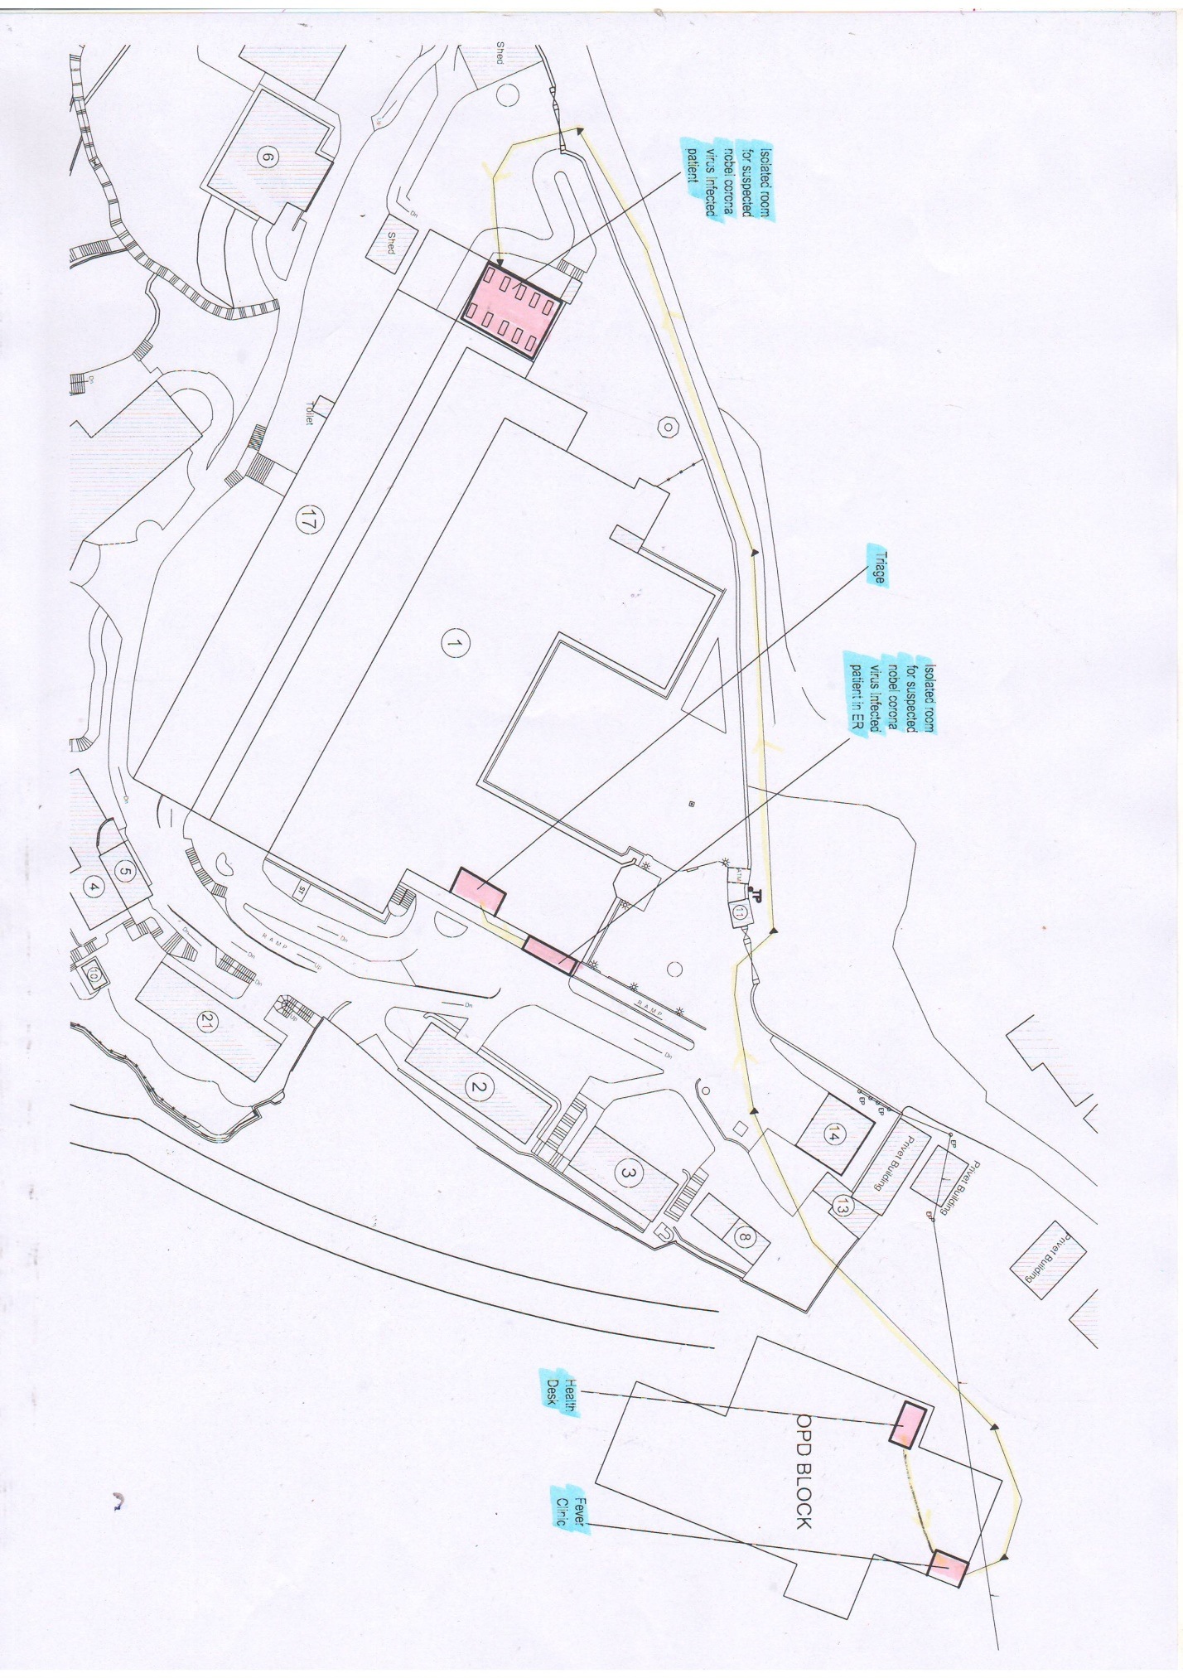

Diagram of triage and treatment areas

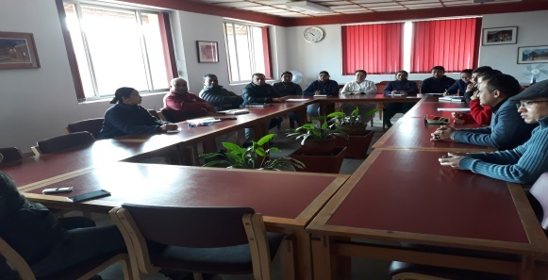



EMERGENCY MEETING AT DHKUH